barry’s adventure documentation

1. **Group Name**

ProApp

1. **Members**

|  |  |  |  |
| --- | --- | --- | --- |
|  | **Name** | **Email** | **ID** |
| **1** | Hamad Ahmad | hamad.ahmad@georgebrown.ca | 101006399 |
| **2** | Mentesnot Aboset | mentesnot.aboset@georgebrown.ca | 101022050 |
| **3** | Toan Nguyen | toan.nguyen2@georgebrown.ca | 100979753 |
| **4** | Zheng Liu | zheng.liu2@georgebrown.ca | 100970328 |

1. **Game Title**

Barry’s Adventure

1. **Game Description**

Barry’s Adventure is a 2D platformer game that has 3 levels. The features of the game include, hunting a hidden treasure, avoiding obstacles and enemies, and collecting points and lives. The player must avoid obstacles and enemies and collect all gold crystals to get to the next level. Collecting coins gain extra points, while collecting heart crystals give an extra life.

1. **Game Layout**
2. **Start:**



1. **Grassland:**

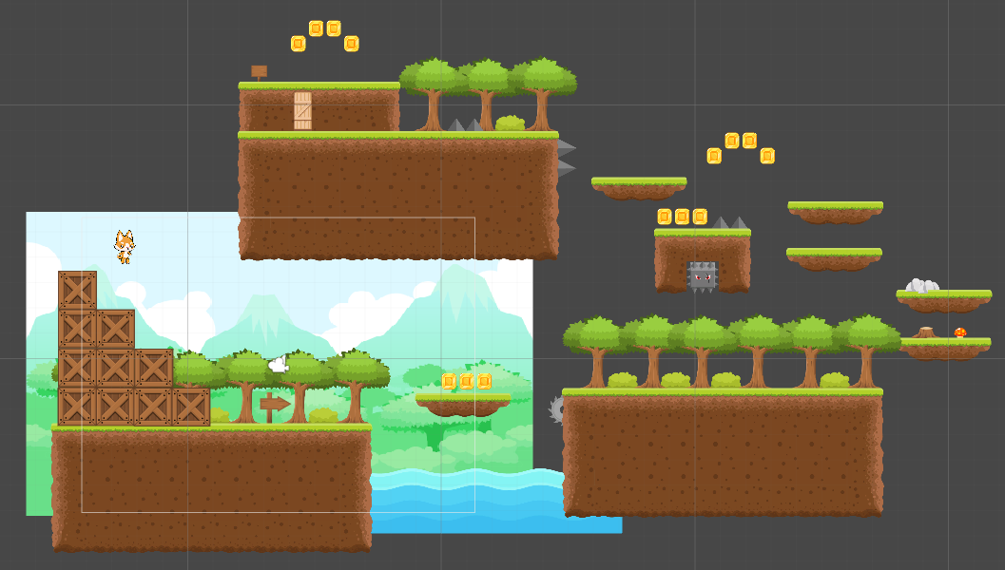

1. **Desert:**

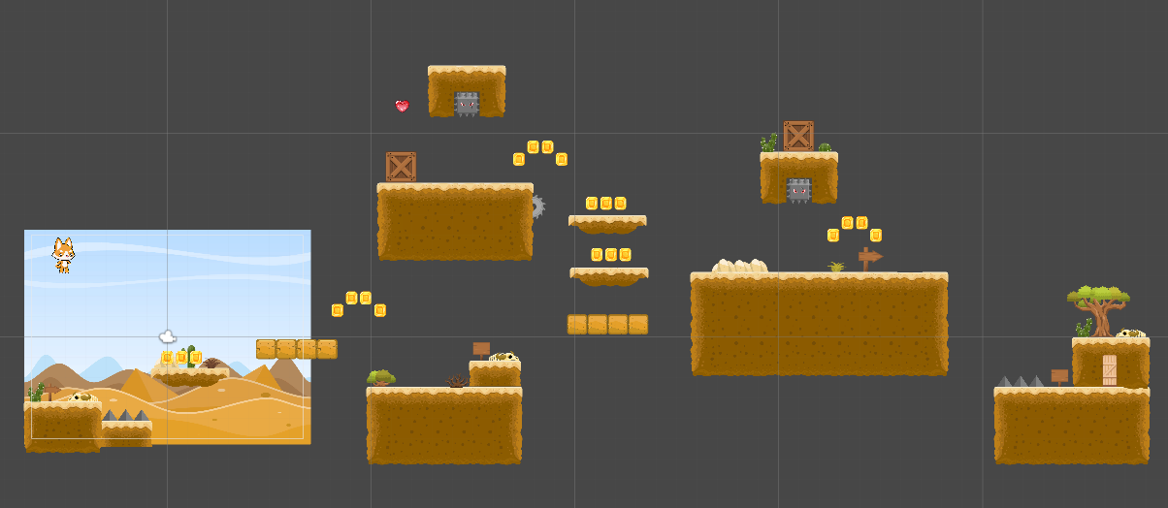

1. **Winter:**

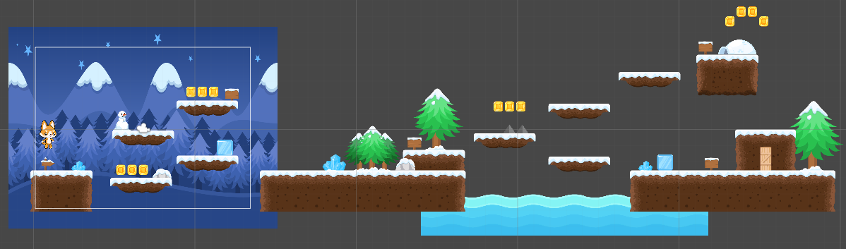

1. **Game Over:**

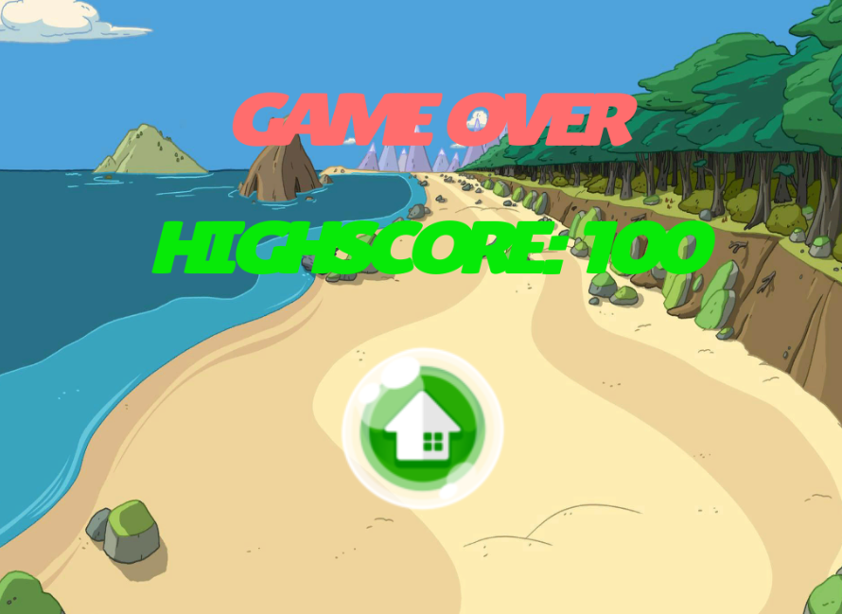

1. **Win:**

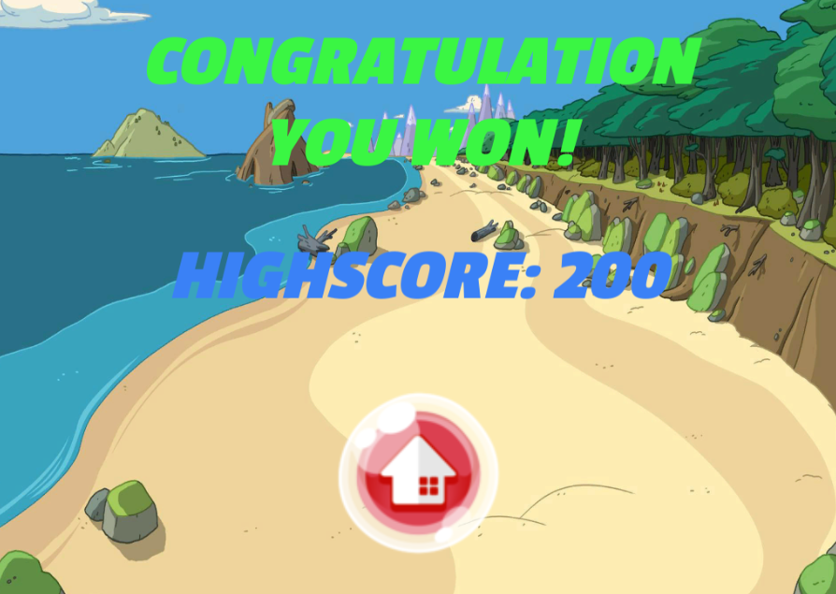

1. **UI Flow Diagram**

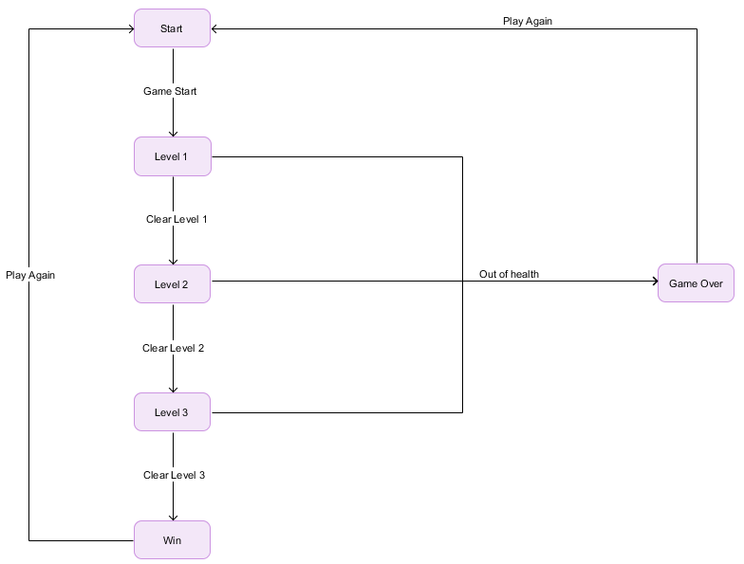

1. **Assets**
2. **Character**

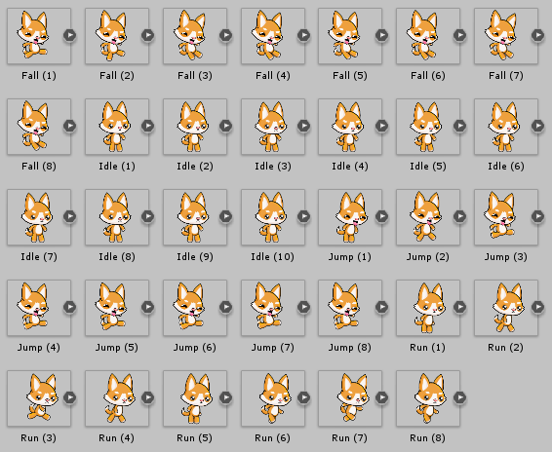

1. **Sprites**

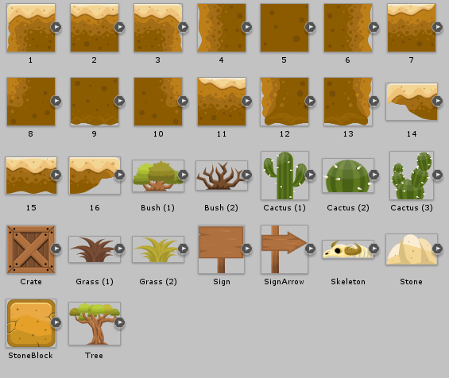



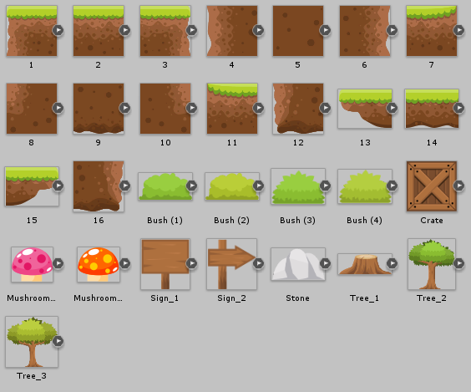





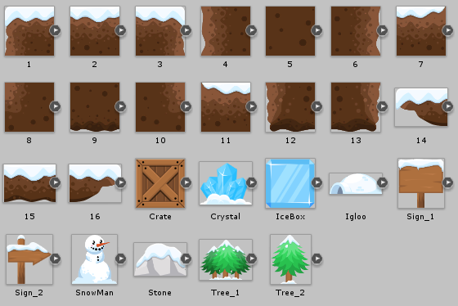

1. **Sounds**











1. **Background**



1. **Backstory**

On December 16th, 1991 at a secret laboratory hidden somewhere in Canada, an experiment went fatally wrong. The lab experiment involved infusing some mysterious pills and substances with a wild dog. The scientists had hoped this would make the dog behave well, to make a product that makes dogs obedient. The results were unexpected. Instead of making the wild dog obedient, they had made it very human-like. The dog began to walk with two paws instead of all four, and seemed much smarter. Thus, was the start of Barry, the dog that possessed human intelligence. After the experiment ended, he quickly escaped the laboratory and ended up outside in the middle of nowhere. Because one of the substances used in the experiment was gold, Barry ended up having an insatiable craving for gold. He only sought-after treasure, and so began his journey to satisfy this craving. He became known as Barry the treasure hunting dog.

1. **Game Mechanics**

Use Left, Right or A, D to move character to left or right

Use Spacebar to jump

This 2D platformer is centered on Barry the treasure hunting dog and as such, many of the game's mechanics revolve around him. The basic mechanic of movement is done through using the arrow keys to move Barry. The left arrow key moves Barry to the left, the right arrow key moves him to the right. The Spacebar key is used to make Barry jump, this is used to help him traverse through the terrain and levels of the game. Since the mechanic of jumping is involved, so is the mechanic of gravity. The movement mechanics will all be implemented using 2D physics. Some of the game's mechanics apart from Barry, would be the instant death that is caused by bottomless pits. As well as the giant spike enemies that will lower Barry's life. This game has levels and upon completion of the final level, the game is finished.